Go For It
By: Flora Chun
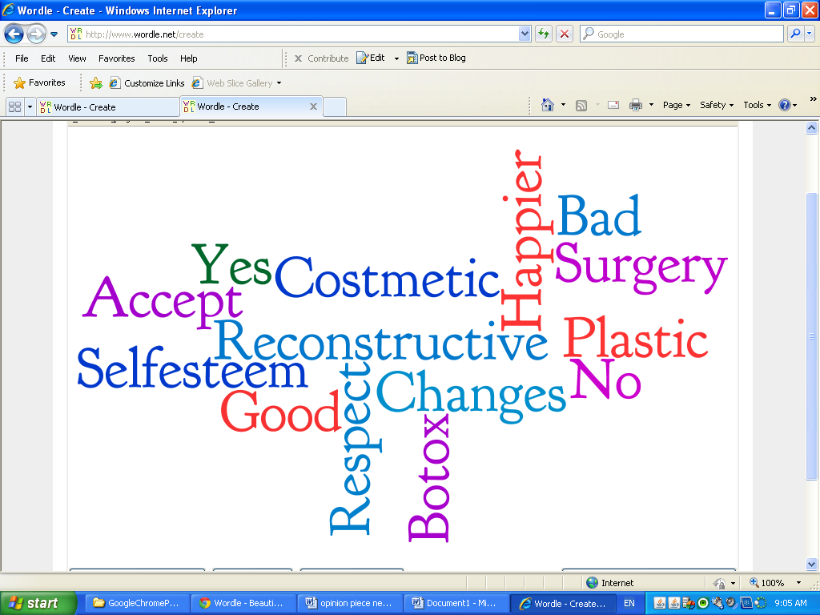

Did you know that around 5.67 million people have had Botox? I believe that plastic surgery should be accepted into our society and people who do choose to get it should not be looked down upon. I will be proving how plastic surgery helps the patients and their self esteem, it is a choice that should be respected, and lastly, it isn’t all about cosmetics, this procedure can also be reconstructive.
Plastic surgery can rocket someone’s level of self esteem. Some people may have had to live their lives feeling no confidence in themselves, and having no pride in how they look. Would you want to live that way? If that was you, wouldn’t you want to try to do anything possible to change the way you look so that you can live your life happily? Well, that is one of the reasons people get plastic surgery. It helps with a great deal with making them comfortable with themselves, and being able to keep going on with their lives without having to be held back with their looks. It will also give them self esteem which helps them in their relationships with others and help them find a spouse. Plastic surgery can change one’s life, how they look at themselves, and how others look at them for the better.
Everyone in this world has the right to choose what they want to do, even if it involves changing the way they look through surgery. The article “Point: Cosmetic Surgery Is a Beneficial Procedure” by Therese Parent and Lee Tunstall says, “If people have the money and they want to, there’s nothing wrong with it.” I don’t think anybody should judge people and their decisions, it has nothing to do with them anyways, and it doesn’t affect them either so why should they care? Everyone chooses a path to take because they have thought about it, have reasoned with it, and decided that that path was going to be the best route for them, and I don’t think anyone has the right stop that person. Plastic surgery is a choice people make, and it is a very serious and important choice that people decide for themselves because it could change their lives; no one has the right to judge that person and their decision on it as well.
This surgery isn’t all about cosmetics; it is used for reconstructive procedures, too. This was created way back after world war one, when the soldiers returned home with wounds and scars. The doctors during that time created this type of surgery to help the soldiers get rid of the wounds on their faces and bodies. Soldiers who returned with burns on their faces from war, got plastic surgery to surgically replace their damaged skin with more acceptable skin, taken from somewhere on their bodies. An example of a more modern day reason for plastic surgery is someone who had fallen down the stairs and got a broken nose. They had no choice but to get plastic surgery to fix their nose. Also think about little children who had to get plastic surgery because they had skin problems when they were born. Even to this day, plastic surgery is used for people who get into accidents and develop wounds; it is also used to eliminate scars, or distorted birthmarks. Just because we refer to this procedure as “plastic” surgery, it doesn’t necessarily make someone “plastic”.
Cosmetic surgery has the potential to change someone’s view on how they look at themselves, others and their lives, and it is a procedure that everyone has a right to choose and nobody should judge or care about that person’s decision, and furthermore, plastic surgery isn’t only used for someone’s greed to look prettier, like a celebrity, but it could be a serious topic for someone who chose to get it to get rid of unwanted memories of an accident that left scars on their skin. People who do choose to get plastic surgery shouldn’t be judged or discriminated against, but should be accepted and respected for their decision. Is it so bad for someone to choose this path in order for them to become happy with themselves and how they are viewed by others?
Face book Discussion: Should Plastic Surgery Be Accepted Into Our Society?
“Who cares if they get it, it has nothing to do with us, and if they have the money and they want it, why not? It makes them happier anyways.” – Anonymous
“I personally think no one should ever get plastic surgery or change the way they look surgically but if they do get it, I don’t think we should judge them for it, they were brave enough to get it, we should at least respect them for that.” - Anonymous

